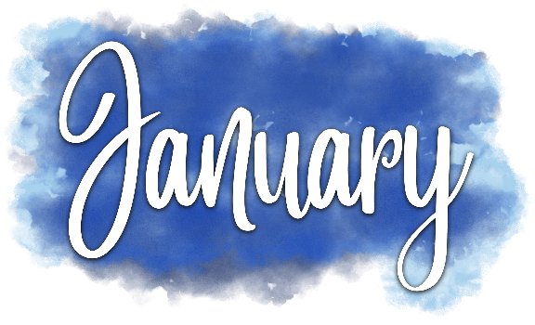
2021

Sunday | Monday | Tuesday | Wednesday | Thursday | Friday | Saturday
 |  |  |  |  | 1 | 2
 |  |  |  |  | New Year’s Day
3 | 4 | 5 | 6 | 7 | 8 | 9
 |  |  | Epiphany
10 | 11 | 12 | 13 | 14 | 15 | 16
17 | 18 | 19 | 20 | 21 | 22 | 23
 | MLK Jr. Day
24 | 25 | 26 | 27 | 28 | 29 | 30
31

2021

Sunday | Monday | Tuesday | Wednesday | Thursday | Friday | Saturday
 | 1 | 2 | 3 | 4 | 5 | 6
 |  | Groundhog Day
7 | 8 | 9 | 10 | 11 | 12 | 13
14 | 15 | 16 | 17 | 18 | 19 | 20
Transfiguration Day Valentine’s Day | Presidents Day |  | Ash Wednesday
21 | 22 | 23 | 24 | 25 | 26 | 27
28

2021

Sunday | Monday | Tuesday | Wednesday | Thursday | Friday | Saturday
 | 1 | 2 | 3 | 4 | 5 | 6
7 | 8 | 9 | 10 | 11 | 12 | 13
14 | 15 | 16 | 17 | 18 | 19 | 20
Daylight-Saving Time Begins |  |  | St. Patrick’s Day |  |  | Spring Begins
21 | 22 | 23 | 24 | 25 | 26 | 27
28 | 29 | 30 | 31
Palm Sunday

2021

Sunday | Monday | Tuesday | Wednesday | Thursday | Friday | Saturday
 |  |  |  | 1 | 2 | 3
 |  |  |  | Maundy Thursday | Good Friday
4 | 5 | 6 | 7 | 8 | 9 | 10
Easter
11 | 12 | 13 | 14 | 15 | 16 | 17
18 | 19 | 20 | 21 | 22 | 23 | 24
 |  |  | Administrative Professionals Day | Earth Day
25 | 26 | 27 | 28 | 29 | 30

2021

Sunday | Monday | Tuesday | Wednesday | Thursday | Friday | Saturday
 |  |  |  |  |  | 1
2 | 3 | 4 | 5 | 6 | 7 | 8
 |  |  |  | National Day of Prayer
9 | 10 | 11 | 12 | 13 | 14 | 15
Mother’s Day |  |  |  | Ascension Day
16 | 17 | 18 | 19 | 20 | 21 | 22
23 | 24 | 25 | 26 | 27 | 28 | 29
30 | 31
Trinity Sunday | Memorial Day

2021

Sunday | Monday | Tuesday | Wednesday | Thursday | Friday | Saturday
 |  | 1 | 2 | 3 | 4 | 5
6 | 7 | 8 | 9 | 10 | 11 | 12
13 | 14 | 15 | 16 | 17 | 18 | 19
 | Flag Day
20 | 21 | 22 | 23 | 24 | 25 | 26
Father’s Day
Summer Begins
27 | 28 | 29 | 30

2021

2021

Sunday | Monday | Tuesday | Wednesday | Thursday | Friday | Saturday
 |  |  |  | 1 | 2 | 3
 |  |  |  | Canada Day
4 | 5 | 6 | 7 | 8 | 9 | 10
Independence Day
11 | 12 | 13 | 14 | 15 | 16 | 17
18 | 19 | 20 | 21 | 22 | 23 | 24
25 | 26 | 27 | 28 | 29 | 30 | 31

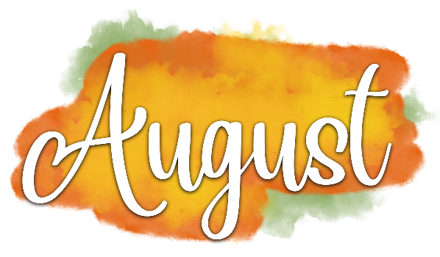
2021

Sunday | Monday | Tuesday | Wednesday | Thursday | Friday | Saturday
1 | 2 | 3 | 4 | 5 | 6 | 7
8 | 9 | 10 | 11 | 12 | 13 | 14
15 | 16 | 17 | 18 | 19 | 20 | 21
22 | 23 | 24 | 25 | 26 | 27 | 28
29 | 30 | 31

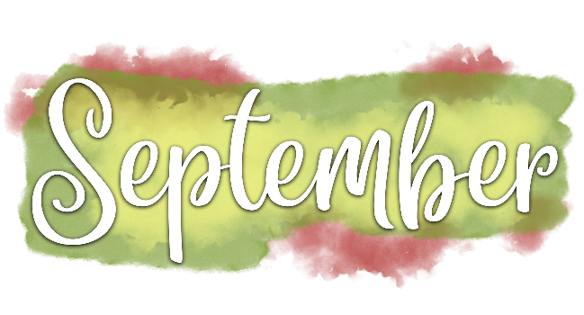

2021
Sunday | Monday | Tuesday | Wednesday | Thursday | Friday | Saturday
 |  |  | 1 | 2 | 3 | 4
5 | 6 | 7 | 8 | 9 | 10 | 11
 | Labor Day |  |  |  |  | Patriot Day
12 | 13 | 14 | 15 | 16 | 17 | 18
Grandparents Day
19 | 20 | 21 | 22 | 23 | 24 | 25
 |  |  | Autumn Begins
26 | 27 | 28 | 29 | 30
2021

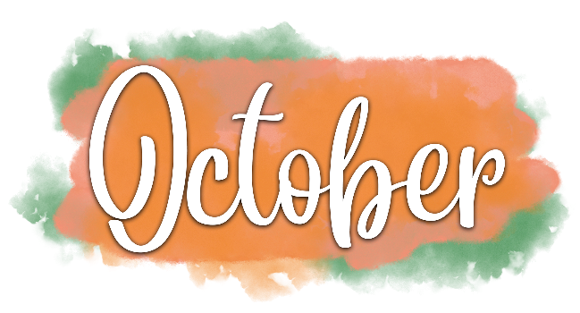

Sunday | Monday | Tuesday | Wednesday | Thursday | Friday | Saturday
 |  |  |  |  | 1 | 2
3 | 4 | 5 | 6 | 7 | 8 | 9
World Communion Sunday
10 | 11 | 12 | 13 | 14 | 15 | 16
Columbus Day
Canadian Thanksgiving
17 | 18 | 19 | 20 | 21 | 22 | 23
24 | 25 | 26 | 27 | 28 | 29 | 30
31
Reformation Day

2021
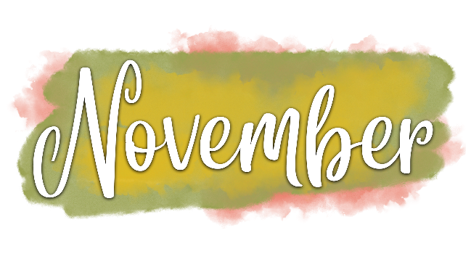

Sunday | Monday | Tuesday | Wednesday | Thursday | Friday | Saturday
 | 1 | 2 | 3 | 4 | 5 | 6
 | All Saints Day
7 | 8 | 9 | 10 | 11 | 12 | 13
Daylight-Saving  Time Ends |  |  |  | Veterans Day
14 | 15 | 16 | 17 | 18 | 19 | 20
21 | 22 | 23 | 24 | 25 | 26 | 27
 |  |  |  | Thanksgiving
28 | 29 | 30
Advent Begins

2021

Sunday | Monday | Tuesday | Wednesday | Thursday | Friday | Saturday
 |  |  | 1 | 2 | 3 | 4
5 | 6 | 7 | 8 | 9 | 10 | 11
12 | 13 | 14 | 15 | 16 | 17 | 18
19 | 20 | 21 | 22 | 23 | 24 | 25
 |  | Winter Begins |  |  | Christmas Eve | Christmas Day
26 | 27 | 28 | 29 | 30 | 31
 |  |  |  |  | New Year’s Eve
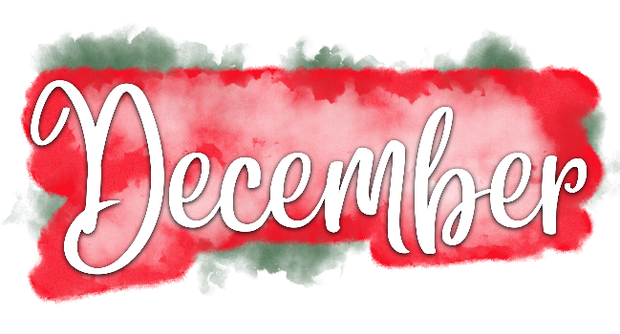
2021

