2022
Sunday | Monday | Tuesday | Wednesday | Thursday | Friday | Saturday
 |  |  |  |  |  | 1
 |  |  |  |  |  | New Year’s Day
2 | 3 | 4 | 5 | 6 | 7 | 8
 |  |  |  | Epiphany
9 | 10 | 11 | 12 | 13 | 14 | 15
16 | 17 | 18 | 19 | 20 | 21 | 22
 | MLK Jr. Day
23 | 24 | 25 | 26 | 27 | 28 | 29
30 | 31
2022
Sunday | Monday | Tuesday | Wednesday | Thursday | Friday | Saturday
 |  | 1 | 2 | 3 | 4 | 5
 |  |  | Groundhog Day
6 | 7 | 8 | 9 | 10 | 11 | 12
13 | 14 | 15 | 16 | 17 | 18 | 19
 | Valentine’s Day
20 | 21 | 22 | 23 | 24 | 25 | 26
 | Presidents Day
27 | 28
Transfiguration Day

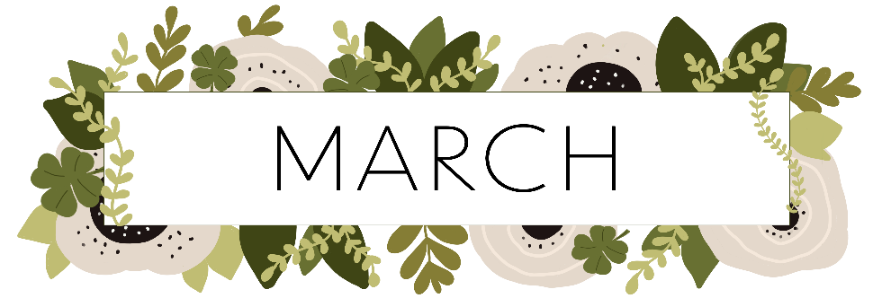
2022
Sunday | Monday | Tuesday | Wednesday | Thursday | Friday | Saturday
 |  | 1 | 2 | 3 | 4 | 5
 |  |  | Ash Wednesday
6 | 7 | 8 | 9 | 10 | 11 | 12
13 | 14 | 15 | 16 | 17 | 18 | 19
Daylight Saving  Time Begins |  |  |  | St. Patrick’s Day
20 | 21 | 22 | 23 | 24 | 25 | 26
Spring Begins
27 | 28 | 29 | 30 | 31

2022
Sunday | Monday | Tuesday | Wednesday | Thursday | Friday | Saturday
 |  |  |  |  | 1 | 2
3 | 4 | 5 | 6 | 7 | 8 | 9
10 | 11 | 12 | 13 | 14 | 15 | 16
Palm Sunday |  |  |  | Maundy Thursday | Good Friday
17 | 18 | 19 | 20 | 21 | 22 | 23
Easter
24 | 25 | 26 | 27 | 28 | 29 | 30
 |  |  | Administrative Professionals Day

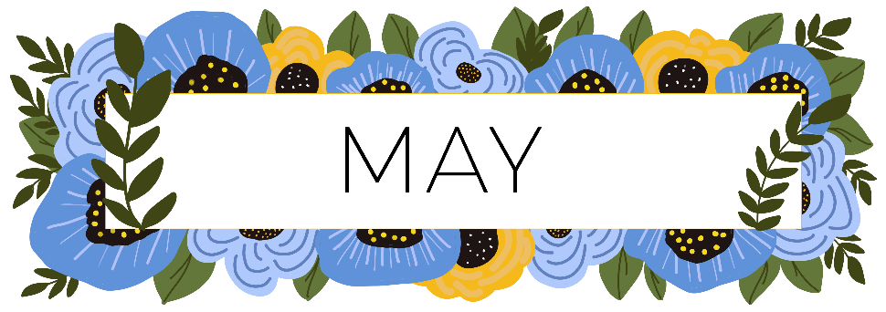
2022
Sunday | Monday | Tuesday | Wednesday | Thursday | Friday | Saturday
1 | 2 | 3 | 4 | 5 | 6 | 7
 |  |  |  | National Day of Prayer
8 | 9 | 10 | 11 | 12 | 13 | 14
Mother’s Day
15 | 16 | 17 | 18 | 19 | 20 | 21
22 | 23 | 24 | 25 | 26 | 27 | 28
 |  |  |  | Ascension Day
29 | 30 | 31
 | Memorial Day

2022
Sunday | Monday | Tuesday | Wednesday | Thursday | Friday | Saturday
 |  |  | 1 | 2 | 3 | 4
5 | 6 | 7 | 8 | 9 | 10 | 11
Pentecost
12 | 13 | 14 | 15 | 16 | 17 | 18
Trinity Sunday |  | Flag Day
19 | 20 | 21 | 22 | 23 | 24 | 25
Father’s Day |  | Summer Begins
26 | 27 | 28 | 29 | 30

2022
Sunday | Monday | Tuesday | Wednesday | Thursday | Friday | Saturday
 |  |  |  |  | 1 | 2
 |  |  |  |  | Canada Day
3 | 4 | 5 | 6 | 7 | 8 | 9
 | Independence Day
10 | 11 | 12 | 13 | 14 | 15 | 16
17 | 18 | 19 | 20 | 21 | 22 | 23
24 | 25 | 26 | 27 | 28 | 29 | 30
31

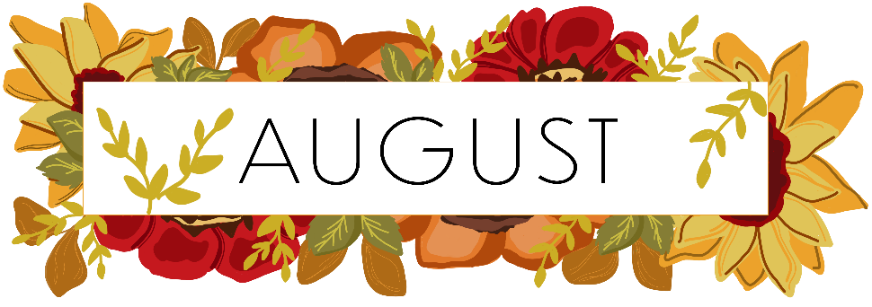
2022
Sunday | Monday | Tuesday | Wednesday | Thursday | Friday | Saturday
 | 1 | 2 | 3 | 4 | 5 | 6
7 | 8 | 9 | 10 | 11 | 12 | 13
14 | 15 | 16 | 17 | 18 | 19 | 20
21 | 22 | 23 | 24 | 25 | 26 | 27
28 | 29 | 30 | 31

2022
Sunday | Monday | Tuesday | Wednesday | Thursday | Friday | Saturday
 |  |  |  | 1 | 2 | 3
4 | 5 | 6 | 7 | 8 | 9 | 10
 | Labor Day
11 | 12 | 13 | 14 | 15 | 16 | 17
Grandparents Day
Patriot Day
18 | 19 | 20 | 21 | 22 | 23 | 24
 |  |  |  | Autumn Begins
25 | 26 | 27 | 28 | 29 | 30

2022
Sunday | Monday | Tuesday | Wednesday | Thursday | Friday | Saturday
 |  |  |  |  |  | 1
2 | 3 | 4 | 5 | 6 | 7 | 8
World Communion Sunday
9 | 10 | 11 | 12 | 13 | 14 | 15
Columbus Day
Canadian Thanksgiving
16 | 17 | 18 | 19 | 20 | 21 | 22
23 | 24 | 25 | 26 | 27 | 28 | 29
30 | 31
 | Reformation Day

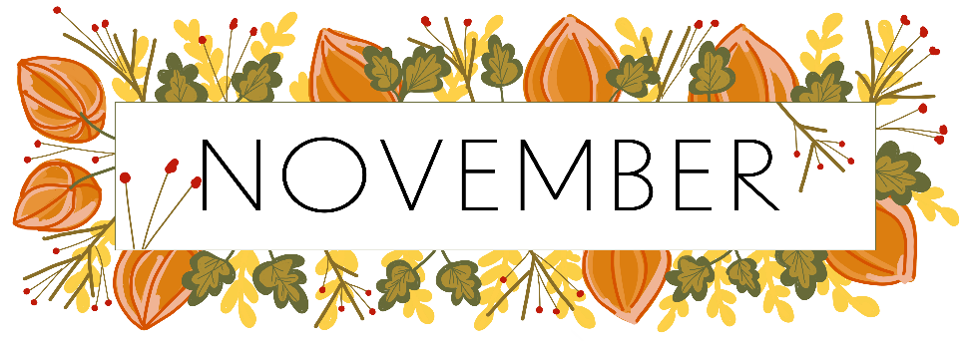
2022
Sunday | Monday | Tuesday | Wednesday | Thursday | Friday | Saturday
 |  | 1 | 2 | 3 | 4 | 5
 |  | All Saints’ Day
6 | 7 | 8 | 9 | 10 | 11 | 12
Daylight Saving
Time Ends
13 | 14 | 15 | 16 | 17 | 18 | 19
20 | 21 | 22 | 23 | 24 | 25 | 26
 |  |  |  | Thanksgiving
27 | 28 | 29 | 30
Advent Begins

2022
Sunday | Monday | Tuesday | Wednesday | Thursday | Friday | Saturday
 |  |  |  | 1 | 2 | 3
4 | 5 | 6 | 7 | 8 | 9 | 10
11 | 12 | 13 | 14 | 15 | 16 | 17
18 | 19 | 20 | 21 | 22 | 23 | 24
 |  |  | Winter Begins |  |  | Christmas Eve
25 | 26 | 27 | 28 | 29 | 30 | 31
Christmas Day |  |  |  |  |  | New Year’s Eve

