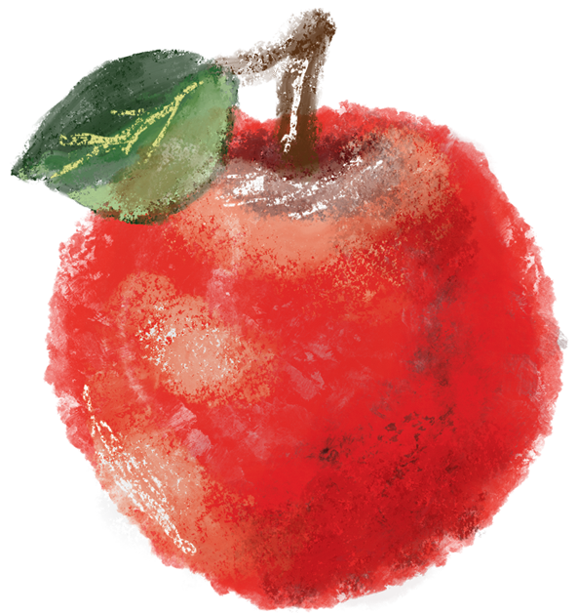

Teacher   
Cards

by



Instructions

Print and cut out the cards on light gray lines. Then you can do all sorts of things with the Teacher cards.  
- Write a heartfelt, handwritten thank you note to a teacher.   
- Attach card with a message to flowers, a gift card to their favorite store, favorite candy or even an apple.  
- Tape to a handmade craft from the student.   
- Print enough cards off for the entire class to write a note of appreciation and give to the teacher.

© 2021 CRI | www.ChurchArt.com

