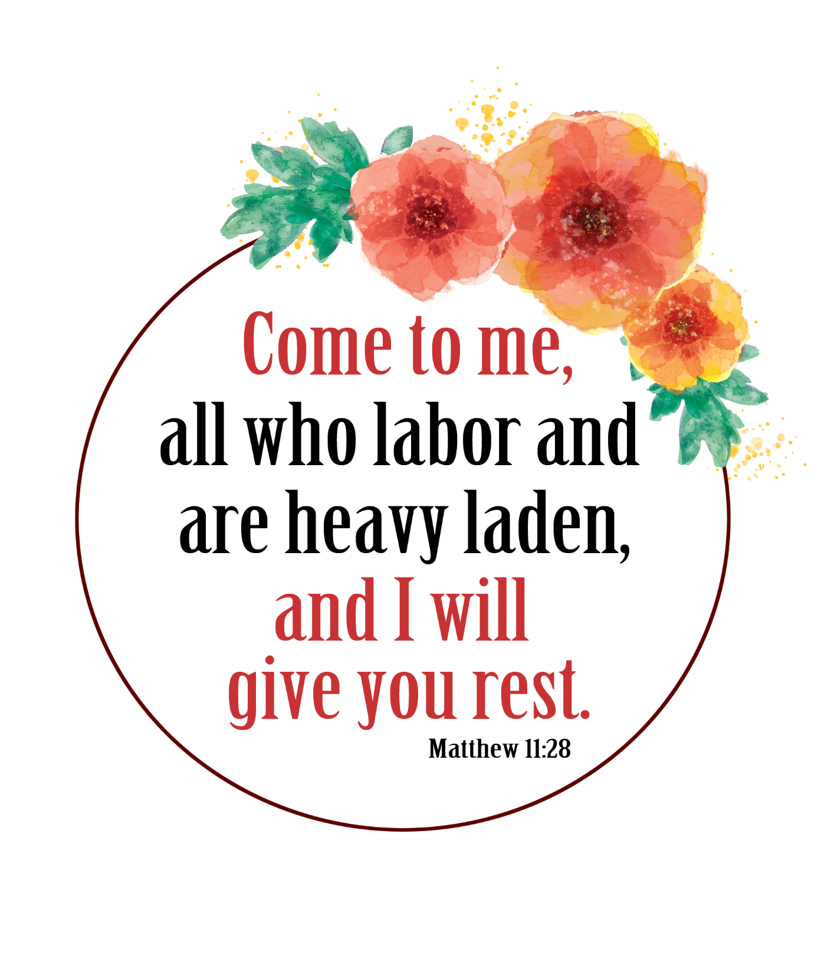

Instructions

Print and cut out the notecards on light gray lines. Fold the cards in half and add your own personal message inside.   
- Give it to a neighbor or mail to someone who is alone.   
- Send one to nursing home staff, nurse or doctor.  
- Give one to a grocery worker, food service provider or other essential worker.  
- Include them in care packages.

All verses are ESV   
© 2020 CRI | www.ChurchArt.com

Scripture   
Notecards

by



Made with Love  
© 2020 CRI

Made with Love  
© 2020 CRI

Made with Love  
© 2020 CRI

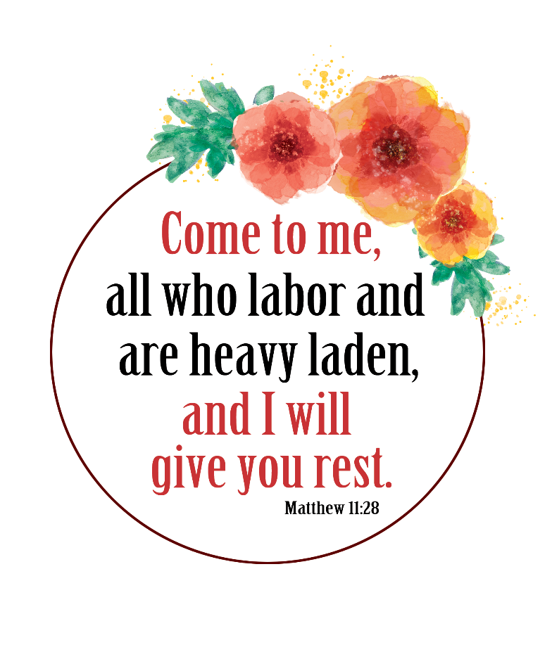

Made with Love  
© 2020 CRI

Made with Love  
© 2020 CRI

Made with Love  
© 2020 CRI

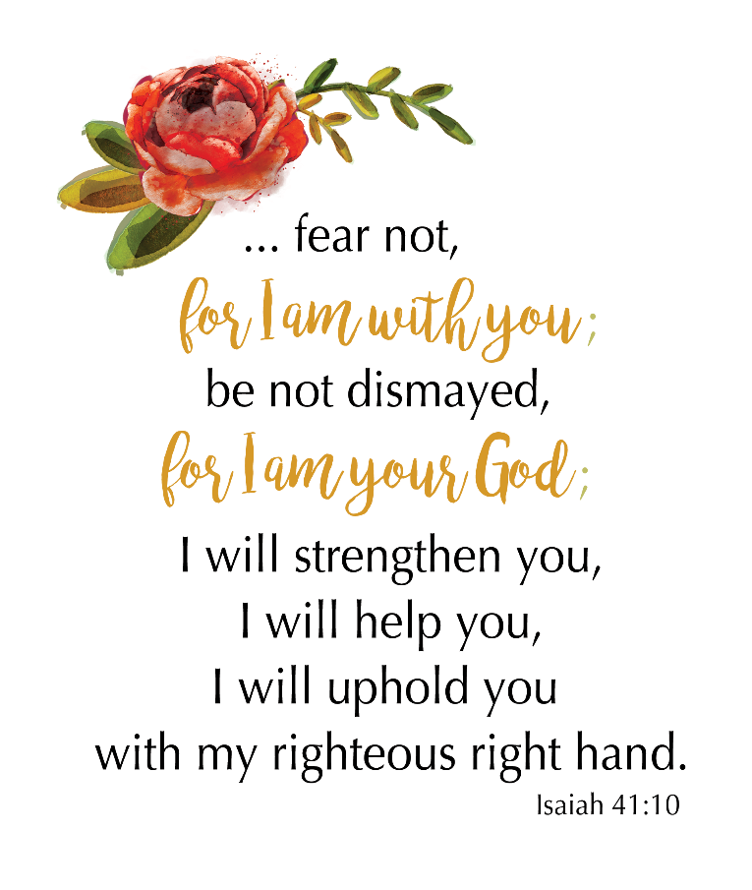



Made with Love  
© 2020 CRI

Made with Love  
© 2020 CRI

Made with Love  
© 2020 CRI



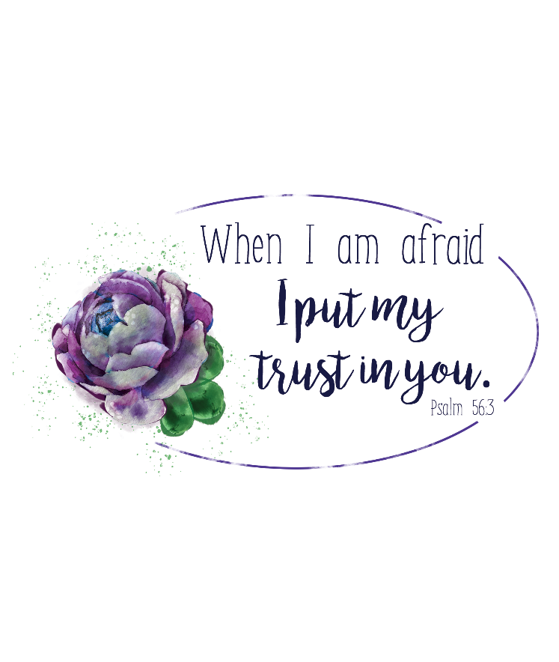

Made with Love  
© 2020 CRI

Made with Love  
© 2020 CRI

Made with Love  
© 2020 CRI

